19.29: For an ideal gas 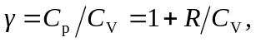and so 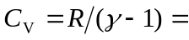
and 